25 Shocking facts about Lord Krishna no one knows!
By Pravin Agrawal
Posted on Oct 18, 2014 at 05:04 pm
1
1.
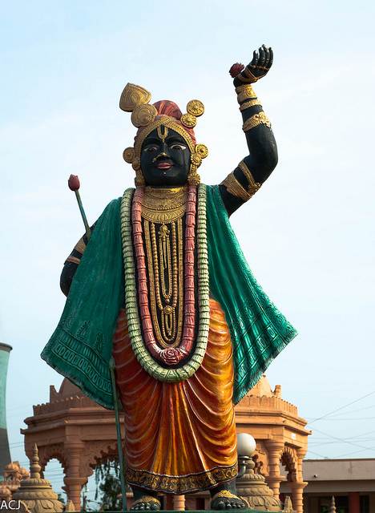
1. The Sanskrit word in its origin language Kṛṣṇa is primarily an adjective meaning "black" or "dark", sometimes it is also translated as "all attractive", according to members of the Hare Krishna movement. As a name of Vishnu, Krishna listed as the 57th Name in the Vishnu Sahasranama. Based on His Name, Krishna is often depicted in murtis as black or blue-skinned. Krishna is also known by various other names, epithets and titles, which reflect His many associations and attributes. Among the most common Names are Mohan "enchanter", Govinda, "Finder of the cows", or Gopala, "Protector of the cows", which refer to Krishna's Childhood in Braj (in present day Uttar Pradesh). Some of the distinct names may be regionally important; for instance, Jagannatha, a popular Incarnation of Puri, Odisha in eastern India.
2
2.
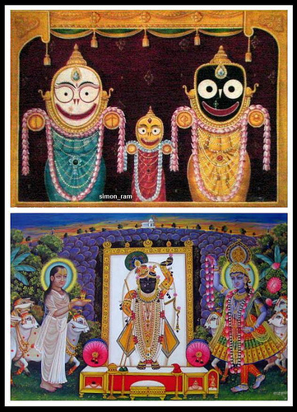
2. A steatite (soapstone) tablet unearthed from Mohenjo-daro, Larkana district, Sindh depicting a young boy uprooting two trees from which are emerging two human figures is an interesting archaeological find for fixing dates associated with Krishna. This image recalls the Yamalarjuna episode of Bhagavata and Harivamsa Purana. In this image, the young boy is undoubtedly Krishna, and the two human beings emerging from the trees are the two cursed gandharvas, identified as Nalakubara and Manigriva. Dr. E.J.H. Mackay, who did the excavation at Mohanjodaro, compares this image with the Yamalarjuna episode. Prof. V.S. Agrawal has also accepted this identification. Thus, it seems that the Indus valley people knew stories related to Krishna. This lone find may not establish Krishna as contemporary with Pre-Indus or Indus times, but, likewise, it cannot be ignored.
3
3.
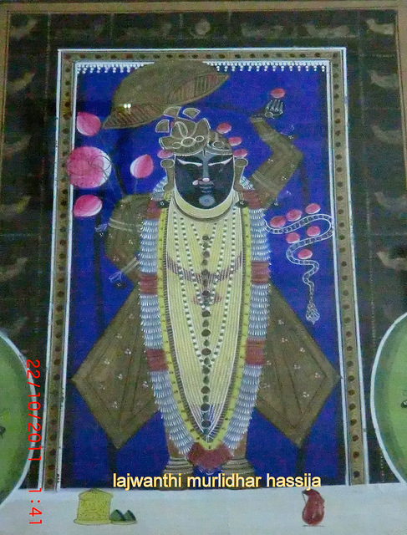
3. The earliest text to explicitly provide detailed descriptions of Krishna as a personality is the epic Mahabharata which depicts Krishna as an incarnation of Vishnu. Krishna is central to many of the main stories of the epic. The eighteen chapters of the sixth book (Bhishma Parva) of the epic that constitute the Bhagavad Gita contain the advice of Krishna to the warrior-hero Arjuna, on the battlefield. Krishna is already an adult in the epic, although there are allusions to his earlier exploits. The Harivamsa, a later appendix to this epic, contains the earliest detailed version of Krishna's childhood and youth.
4
4.
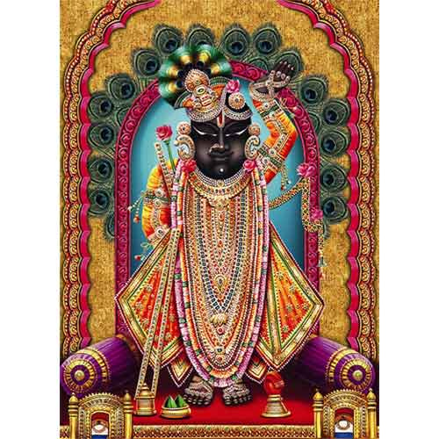
4. The Rig Veda 1.22.164 sukta 31 mentions a herdsman "who never stumbles". Some Vaishnavite scholars, such as Bhaktivinoda Thakura, claim that this herdsman refers to Krishna. Ramakrishna Gopal Bhandarkar also attempted to show that "the very same Krishna" made an appearance, e.g. as the drapsa, krishna "black drop" of RV 8.96.13. Some authors have also likened prehistoric depictions of deities to Krishna.
5
5.
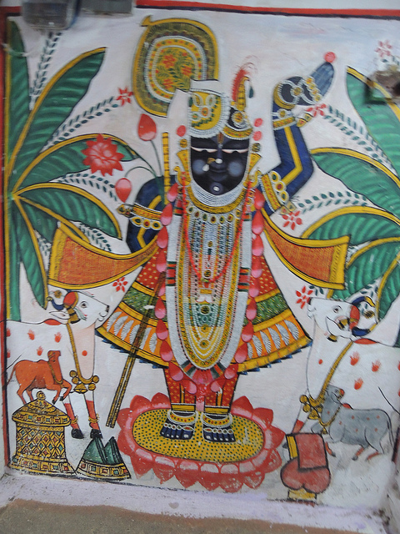
5. Around 150 BC, Patanjali in his Mahabhashya quotes a verse: "May the might of Krishna accompanied by Samkarshana increase!" Other verses are mentioned. One verse speaks of "Janardhana with himself as fourth" (Krishna with three companions, the three possibly being Samkarshana, Pradyumna, and Aniruddha). Another verse mentions musical instruments being played at meetings in the temples of Rama (Balarama) and Kesava (Krishna). Patanjali also describes dramatic and mimetic performances (Krishna-Kamsopacharam) representing the killing of Kamsa by Vasudeva.
6
6.
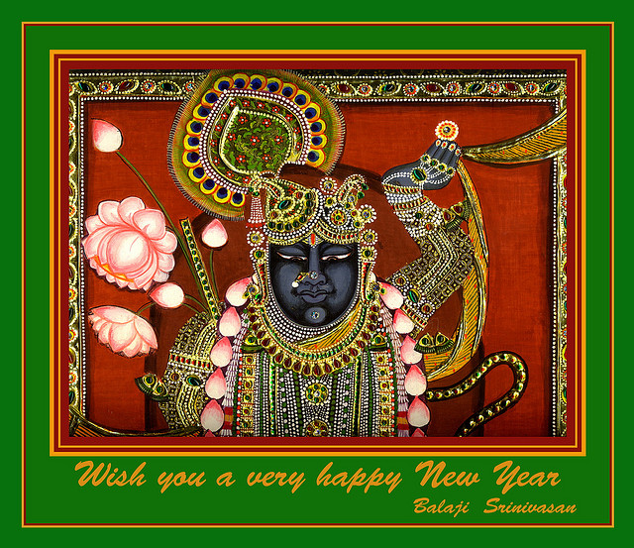
6. In the 1st century BC, there seems to be evidence for a worship of five Vrishni heroes (Balarama, Krishna, Pradyumna, Aniruddha and Samba) for an inscription has been found at Mora near Mathura, which apparently mentions a son of the great satrap Rajuvula, probably the satrap Sodasa, and an image of Vrishni, "probably Vasudeva, and of the "Five Warriors". Brahmi inscription on the Mora stone slab, now in the Mathura Museum.
7
7.
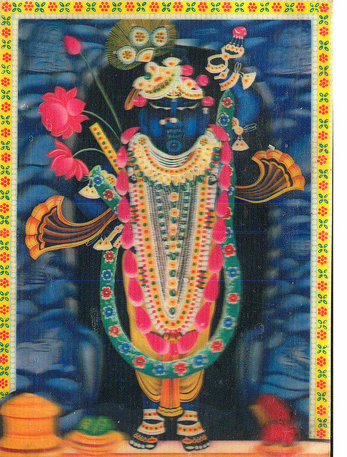
7. Krishna killed the demoness Putana, disguised as a wet nurse, and the tornado demon Trinavarta both sent by Kansa for Krishna's life. He tamed the serpent Kāliyā, who previously poisoned the waters of Yamuna river, thus leading to the death of the cowherds. In Hindu art, Krishna is often depicted dancing on the multi-hooded Kāliyā.
8
8.
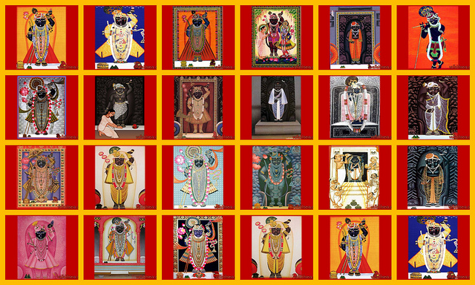
8. Krishna lifted the Govardhana hill and taught Indra, the king of the devas, a lesson to protect native people of Brindavana from persecution by Indra and prevent the devastation of the pasture land of Govardhan. Indra had too much pride and was angry when Krishna advised the people of Brindavana to take care of their animals and their environment that provide them with all their necessities, instead of worshipping Indra annually by spending their resources. In the view of some, the spiritual movement started by Krishna had something in it which went against the orthodox forms of worship of the Vedic gods such as Indra. In Bhagavat Purana, Krishna says that the rain came from the nearby hill Govardhana, and advised that the people worshiped the hill instead of Indra. This made Indra furious, so he punished them by sending out a great storm. Krishna then lifted Govardhan and held it over the people like an umbrella.
9
9.
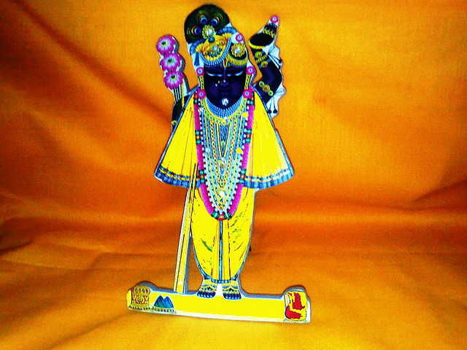
9. Krishna married Rukmini, the Vidarbha princess, by abducting her, at her request, from her proposed wedding with Shishupala. He married eight queens—collectively called the Ashtabharya—including Rukmini, Satyabhama, Jambavati, Kalindi, Mitravinda, Nagnajiti, Bhadra and Lakshmana. Krishna subsequently married 16,000 or 16,100 maidens who were held captive by the demon Narakasura, to save their honour. Krishna killed the demon and released them all. According to social custom of the time, all of the captive women were degraded, and would be unable to marry, as they had been under the Narakasura's control. However Krishna married them to reinstate their status in the society. This symbolic wedding with 16,100 abandoned daughters was more of a mass women rehabilitation. In Vaishnava traditions, Krishna's wives are forms of the goddess Lakshmi— consort of Vishnu, or special souls who attained this qualification after many lifetimes of austerity, while his two queens, Rukmani and Satyabhama, are expansions of Lakshmi.
10
10.
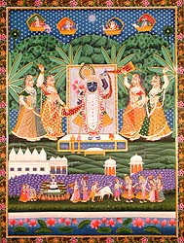
10. When Yudhisthira was assuming the title of emperor, he had invited all the great kings to the ceremony and while paying his respects to them, he started with Krishna because he considered Krishna to be the greatest of them all. While it was a unanimous feeling amongst most present at the ceremony that Krishna should get the first honours, his cousin Shishupala felt otherwise and started berating Krishna. Due to a vow given to Shishupal's mother, Krishna forgave a hundred verbal abuses by Shishupal, and upon the one hundred and first, he assumed his Virat (universal) form and killed Shishupal with his Chakra. The blind king Dhritarashtra also obtained divine vision during this time to be able to see this form of Krishna. Essentially, Shishupala and Dantavakra were both re-incarnations of Vishnu's gate-keepers Jaya and Vijaya, who were cursed to be born on Earth, to be delivered by the Vishnu back to Vaikuntha.
11
11.
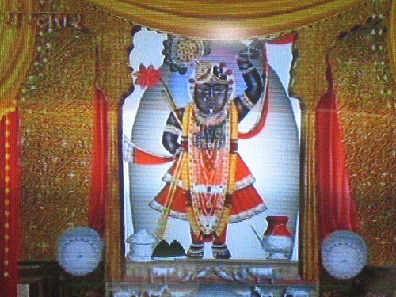
11. Krishna had eight princely wives, also known as Ashtabharya, or patrani (Rukmini, Satyabhama, Jambavati, Nagnajiti, Kalindi, Mitravinda, Bhadra, Lakshmana) and the other 16,100 were rescued from Narakasura. They had been forcibly kept in his palace and after Krishna had killed Narakasura he rescued these 16,100 women and freed them. However, all of them returned to Krishna saying that because they had been kept by Narakasura none of their families would accept them and also nobody would marry any of them. So to stop them from being unprotected Krishna married them all on a single day, by taking 16,100 forms. The chief amongst them is sometimes called Rohini. He gave them shelter in his new palace and a respectful place in society. However he never had any relations with those 16,100 women, and many Hindu scriptures describe them as dancing around Krishna, singing songs of praise.
12
12.
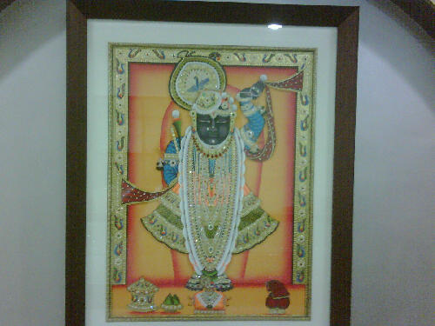
12. The first son of Queen Rukmini was Pradyumna, and also born of her were Charudeshna, Sudeshna and the powerful Charudeha, along with Sucharu, Chharugupta, Bhadracaru, Charuchandra, Vicaru and Caru, the tenth. Pradyumna fathered the greatly powerful Aniruddha in the womb of Rukmavati, the daughter of Rukmi. This took place while they were living in the city of Bhojakata.
13
13.
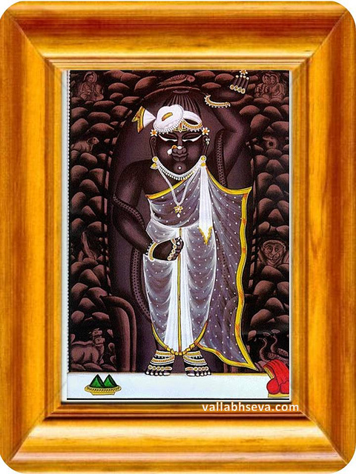
13. The ten sons of Satyabhama were Bhanu, Subhanu, Svarbhanu, Prabhanu, Bhanuman, Chandrabhanu, Brihadbhanu, Atibhanu (the eighth), Sribhanu and Pratibhanu. Krishna is an important deity in Hinduism and seen as a very symbolic Lord. Samba, Sumitra, Purujit, Satajit, Sahasrajit, Vijaya, Citraketu, Vasuman, Dravida and Kratu were the sons of Jambavati. These ten, headed by Samba, were their father's favorites. The sons of Nagnajiti were Vira, Candra, Asvasena, Citragu, Vegavan, Vrisha, Ama, Sanku, Vasu and the opulent Kunti.
14
14.
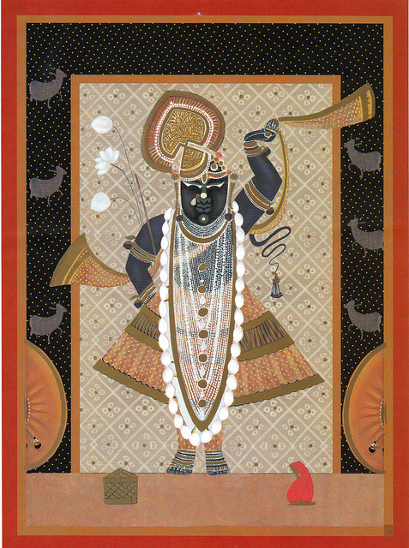
14. Sruta, Kavi, Vrisha, Vira, Subahu, Bhadra, Santi, Darsa and Purnamasa were sons of Kalindi. Her youngest son was Somaka. Mitravinda's sons were Vrika, Harsha, Anila, Gridhra, Vardhana, Unnada, Mahamsa, Pavana, Vahni and Kshudhi. Sangramajit, Brihatsena, Sura, Praharana, Arijith, Jaya and Subhadra were the sons of Bhadra, together with Vama, Ayur and Satyaka. Lakshmana's sons were Praghosha, Gatravan, Simha, Bala, Prabala, Urdhaga, Mahasakti, Saha, Oja and Aparajita. Diptiman, Tamratapta and others were the sons of Krishna and Rohini.
15
15.
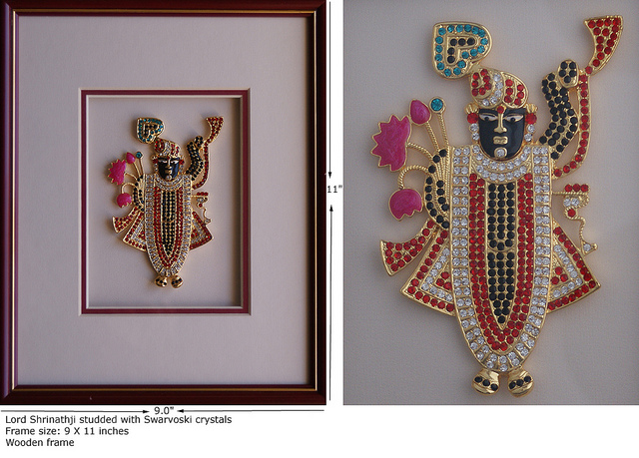
15. According to Mahabharata, the Kurukshetra war resulted in the death of all 100 sons of Gandhari. On the night before Duryodhana's death, Lord Krishna visited Gandhari to offer his condolences. Gandhari felt that Krishna knowingly did not put an end to the war, and in a fit of rage and sorrow, Gandhari cursed that Krishna, along with everyone else from Yadu dynasty, would perish after 36 years. Krishna himself knew and wanted this to happen as he felt that the Yadavas had become very haughty and arrogant (adharmi), so he ended Gandhari's speech by saying "tathastu" (so be it).
16
16.
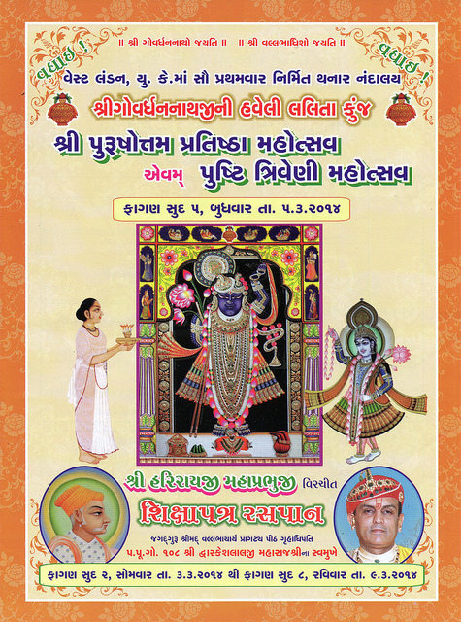
16. Krishna never appears to grow old or age at all in the historical depictions of the Puranas despite passing of several decades, but there are grounds for a debate whether this indicates that he has no material body, since battles and other descriptions of the Mahabhārata epic show clear indications that he seems to be subject to the limitations of nature. While battles apparently seem to indicate limitations, Mahabharata also shows in many places where Krishna is not subject to any limitations as through episodes Duryodhana trying to arrest Krishna where his body burst into fire showing all creation within him.[95] Krishna is also explicitly described as without deterioration elsewhere.
17
17.
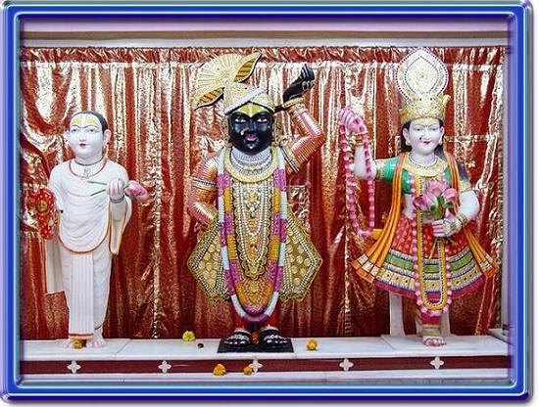
17. The bhakti movements devoted to Krishna became prominent in southern India in the 7th to 9th centuries AD. The earliest works included those of the Alvar saints of the Tamil country. A major collection of their works is the Divya Prabandham. The Alvar Andal's popular collection of songs Tiruppavai, in which she conceives of herself as a gopi, is the most famous of the oldest works in this genre. Kulasekaraazhvaar's Mukundamala was another notable work of this early stage.
18
18.
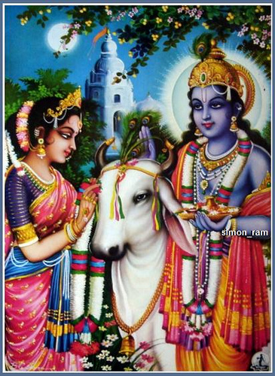
18. In the Deccan, particularly in Maharashtra, saint poets of the Varkari sect such as Dnyaneshwar, Namdev, Janabai, Eknath and Tukaram promoted the worship of Vithoba, a local form of Krishna, from the beginning of the 13th century until the late 18th century. In southern India, Purandara Dasa and Kanakadasa of Karnataka composed songs devoted to the Krishna image of Udupi. Rupa Goswami of Gaudiya Vaishnavism, has compiled a comprehensive summary of bhakti named Bhakti-rasamrita-sindhu.
19
19.
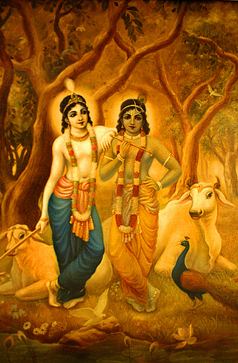
19. In South India, Vaishnavas usually belong to the Sri Sampradaya. The acharyas of the Sri Sampradaya have written reverentially about Krishna in most of their works like the Thiruppavai by Andal and Gopala Vimshati by Vedanta Desika. In South India, devotion to Krishna, as an avatar of Vishnu, spread in the face of opposition to Buddhism, Shaktism, and Shaivism and ritualistic Vedic sacrifices. The acharyas of the Sri Sampradaya like Manavala Mamunigal, Vedanta Desika strongly advocated surrender to Vishnu as the aim of the Vedas. Out of 108 Divya Desams there are 97 Divya Desams in South India.
20
20.
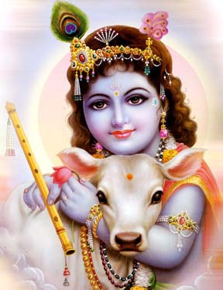
20. From the 10th century AD, with the growing bhakti movement, Krishna became a favorite subject of the arts. The songs of the Gita Govinda became popular across India, and had many imitations. The songs composed by the Bhakti poets added to the repository of both folk and classical singing. The classical Indian dances, especially Odissi and Manipuri, draw heavily on the story. The 'Rasa lila' dances performed in Vrindavan shares elements with Kathak, and the Krisnattam, with some cycles, such as Krishnattam, traditionally restricted to the Guruvayur temple, the precursor of Kathakali.
21
21.
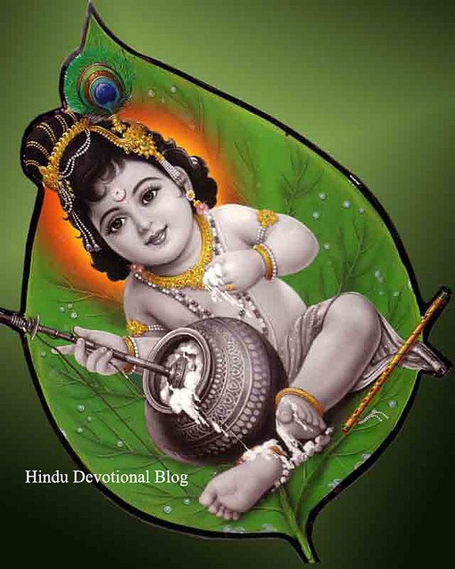
21. The most exalted figures in Jainism are the twenty-four Tirthankaras. Krishna, when he was incorporated into the Jain list of heroic figures, presented a problem with his activities which are not pacifist. The concept of Baladeva, Vasudeva and Prati-Vasudeva was used to solve it. The Jain list of sixty-three Shalakapurshas or notable figures includes, amongst others, the twenty-four Tirthankaras and nine sets of this triad. One of these triads is Krishna as the Vasudeva, Balarama as the Baladeva and Jarasandha as the Prati-Vasudeva. He was a cousin of the twenty-second Tirthankara, Neminatha. The stories of these triads can be found in the Harivamsha of Jinasena (not be confused with its namesake, the addendum to Mahābhārata) and the Trishashti-shalakapurusha-charita of Hemachandra.
22
22.
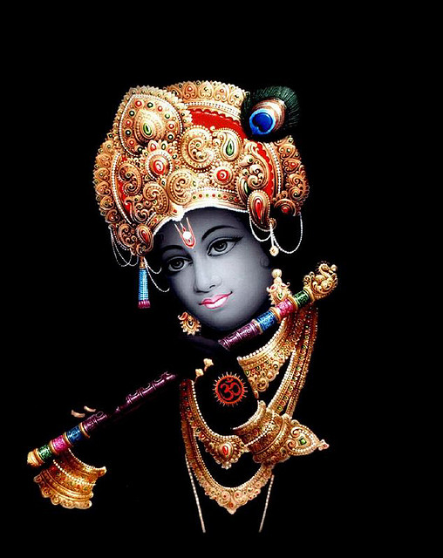
22. The story of Krishna occurs in the Jataka tales in Buddhism, in the Vaibhav Jataka as a prince and legendary conqueror and king of India. In the Buddhist version, Krishna is called Vasudeva, Kanha and Keshava, and Balarama is his older brother, Baladeva. These details resemble that of the story given in the Bhagavata Purana. Vasudeva, along with his nine other brothers (each son a powerful wrestler) and one elder sister (Anjana) capture all of Jambudvipa (many consider this to be India) after beheading their evil uncle, King Kansa, and later all other kings of Jambudvipa with his Sudarshana Chakra. Much of the story involving the defeat of Kansa follows the story given in the Bhagavata Purana.
23
23.
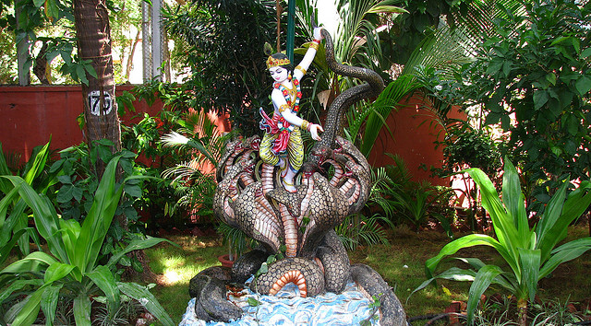
23. Bahá'ís believe that Krishna was a "Manifestation of God", or one in a line of prophets who have revealed the Word of God progressively for a gradually maturing humanity. In this way, Krishna shares an exalted station with Abraham, Moses, Zoroaster, Buddha, Muhammad, Jesus, the Báb, and the founder of the Bahá'í Faith, Bahá'u'lláh.
24
24.
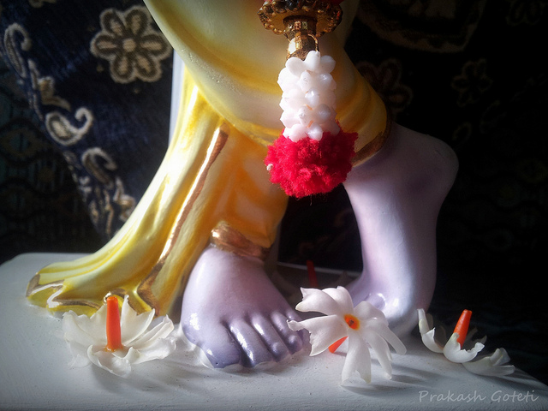
24. Members of the Ahmadiyya Community believe Krishna to be a great prophet of God as described by their founder, Mirza Ghulam Ahmad. This belief is maintained by the Qur'anic Principle that God has sent prophets and messengers to every nation of the world leaving no region without divine guidance (see for instance Quran 10:47 and Quran 16:36). There is also a saying reportedly of the Islamic prophet Muhammad which says There was a prophet of God in India who was dark in colour and his name was Kanha.
25
25.
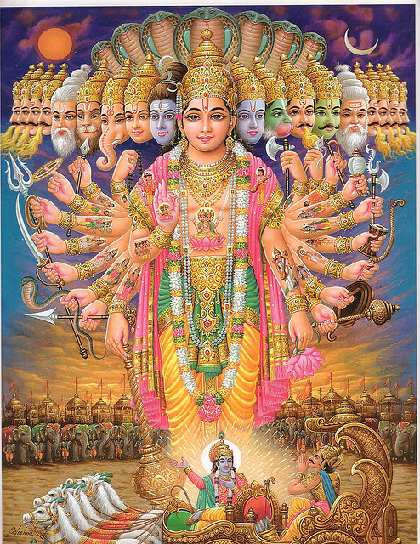
25. Krishna worship or reverence has been adopted by several new religious movements since the 19th century, and he is sometimes a member of an eclectic pantheon in occult texts, along with Greek, Buddhist, Biblical and even historical figures. For instance, Édouard Schuré, an influential figure in perennial philosophy and occult movements, considered Krishna a Great Initiate; while Theosophists regard Krishna as an incarnation of Maitreya (one of the Masters of the Ancient Wisdom), the most important spiritual teacher for humanity along with Buddha. Krishna was canonized by Aleister Crowley and is recognized as a saint in the Gnostic Mass of Ordo Templi Orientis.
26

